Halloween Hideout

Taylor Rosby

CST-452 Capstone Project Proposal

Grand Canyon University

Instructor: Professor Mark Reha

Revision: 1

Date: April 4, 2021

**ABSTRACT**

Halloween Hideout is a 2D iOS platformer centered around surviving Halloween night, from the hours of 7 pm to 7 am. The game will consist three (3) levels, each level will take place at different times in the game will get progressively harder. Throughout the player’s journey they will collect candy pieces with value ranging from one (1) to fifteen (15). These candy pieces will be used in the in-game store to buy costumes that will randomly appear throughout the levels. The player will be able to run, jump, and attack to clear the levels and complete the game.

|  |
| --- |
| History and Signoff Sheet |

**Change Record**

|  |  |  |
| --- | --- | --- |
| **Date** | **Author** | **Revision Notes** |
| 9/27/20 | Tay Rosby | Initial draft for review/discussion |
| 10/11/20 | Tay Rosby | Added a Flow Chart |
| 10/20/20 | Tay Rosby | Added Enemy/Character Draft |
| 11/1/20 | Tay Rosby | Updated Flow Chart |
| 4/4/21 | Tay Rosby | Updated WBS, updated Flow Chart |
|  |  |  |

|  |
| --- |
| **Overall Instructor Feedback/Comments** |

|  |
| --- |
| **Overall Instructor Feedback/Comments** |

**Integrated Instructor Feedback into Project Documentation**

Yes  No

**Project Approval**

Professor Mark Reha

**TABLE OF CONTENTS**

Project Overview and Project Objectives 4

Project Scope 5

Project Success Measures 7

Project High-Level Solution 8

Project Controls 9

Appendix A – References 10

Appendix B – Copyright Compliance 11

Project Overview and Project Objectives

**State the Problem and Background**

The purpose of this application is to develop a 2D iOS platformer that will allow a player to go through multiple levels varying in difficulty in order to survive the night. The goal is to develop a game that is easy to use, distracts some users from stressful events in their lives, and provides mindless entertainment to others.

Halloween Hideout is a passion project for the developer who wanted to find to mix love of video games with wanting to create an application that will help others. This can be as simple as taking someone’s mind off a bad day for a few hours. Halloween Hideout aims to be the game people play when they need a break.

**Project Objectives**

The following list of objectives are going to be used to measure the success of the project

* Trained in Swift and built a functioning iOS application
* Trained in a database so the application will save on the user’s device
* 85 percent of the features in scope completed
* The application has minimal bugs
* The application can be deployed on multiple iPhones and run as intended

**Challenges**

The following list of challenges are going to be used to measure the success of the project

* Having enemies be randomly generated throughout the level
* Ability to learn the Swift language well enough to develop the application
* Ability to connect a database to the application so data is stored on the user’s device
* Ability to develop an in-game store

**Benefits and Opportunities**

* Alleviates stress from users
* Small learning curve
* No microtransactions or subscriptions – no one has a monitorial advantage
* Ad revenue
  + Users have option to double candy collected on a level by watching ads

Project Scope

The following list is the current scope of the project

* Save and resume game
* Player will be able to collect candy
* Three (3) types of candy with values of 1, 5, and 10 respectively
* Enemies will be randomly generated throughout the level
* Player can pick between three (3) characters to play as
* Players will be able to buy costumes from an in-game store that will randomly show up in levels

The following list is items that will be added to the project if time allows

* Additional levels
* Costumes will give players a buff
  + Example: invincibility for 20 seconds
* Integration into the Game Center
* Cloud saves to play game across multiple devices
* Challenge levels
* Leaderboard for challenge levels
* Character creation
* Users able to replay levels
* Ads

|  |  |  |  |  |  |  |  |  |  |  |
| --- | --- | --- | --- | --- | --- | --- | --- | --- | --- | --- |
| Work Breakdown Structure | | | | | | | | | | |
| ID | Task | Dependencies | Status | Effort Hours | Cost | Start Date | Planned Completion | Estimate to Completion | Actual Completion | Resource |
|  | Downloaded XCode | N/A | Completed | 2 | N/A | 9/09/20 | 9/09/20 | N/A | 9/09/20 | N/A |
|  | Completed Hello World Application | N/A | Completed | 10 minutes | N/A | 9/09/20 | 9/09/20 | N/A | 0/09/20 | N/A |
|  | Downloaded Swift and XCode books | N/A | Completed | 1 | N/A | 9/09/20 | 9/09/20 | N/A | 9/09/20 | Apple Books |
|  | Researched Swift tutorials | N/A | Completed | 2 | N/A | 9/11/20 | 9/15/20 | N/A | 9/15/20 | YouTube, Swift Playgrounds |
|  | Researched Swift Gameplay and Sprite Kits | N/A | Completed | 2 | N/A | 9/11/20 | 9/30/20 | N/A | 9/29/20 | Swift Documentation |
|  | Researched similar mobile games | N/A | Completed | 4 | N/A | 9/18/20 | 9/29/20 | N/A | 9/29/20 | App Store, Google Play Store |
|  | Started Swift tutorials | N/A | Completed | 5 | N/A | 9/13/20 | 9/15/20 | N/A | 9/13/20 | YouTube |
|  | First draft of proposal | N/A | Completed | 6 | N/A | 9/11/20 | 9/17/20 | N/A | 9/17/20 | N/A |
|  | Updated draft of proposal | N/A | Completed | 4 | N/A | 9/18/20 | 9/27/20 | N/A | 9/27/20 | N/A |
|  | Complete Lean Canvas Template | N/A | Completed | 3 | N/A | 9/09/20 | 9/13/20 | N/A | 9/13/20 | N/A |
|  | Completed war card game proof of concept app | N/A | Completed | 2.5 | N/A | 9/16/20 | 9/17/20 | N/A | 9/17/20 | YouTube |
|  | Completed matching game proof on concept | N/A | Completed | 4.5 | N/A | 9/22/20 | 9/27/20 | N/A | 9/27/20 | YouTube |
|  | Start working with the Sprite Kit | N/A | Completed | 5 | N/A | 10/2/20 | 10/11/20 | N/A | 10/2/20 | N/A |
|  | Start working with the Gameplay Kit | N/A | Completed | 5 | N/A | 10/2/10 | 10/11/20 | N/A | 10/2/20 | N/A |
|  | Complete last proof of concept app (Space Game) | N/A | Completed | 6 | N/A | 10/15/20 | 10/18/20 | N/A | 10/18/20 | N/A |
|  | Learn about Game Theory | N/A | Completed | 10 | N/A | 10/1/20 | 10/18/20 | N/A | 10/19/20 | N/A |
|  | Researched databases | N/A | Completed | 2 | N/A | 10/15/20 | 10/25/20 | N/A | 10/20/20 | N/A |
|  | Decide on which database to use | N/A | Completed | 1 | N/A | 10/22/20 | 10/25/20 | N/A | 10/23/20 | N/A |
|  | Determine if technology is feasible for application | N/A | Completed | 1 | N/A | 10/22/20 | 10/25/20 | N/A | 10/23/20 | N/A |
|  | Requirements Document Draft | N/A | Completed | 10 | N/A | 9/28/20 | 10/25/20 | N/A | 10/20/20 | N/A |
|  | Completed Requirements Document | N/A | Completed | 5 | N/A | 9/28/20 | 11/1/20 | N/A | 10/31/20 | N/A |
|  | Architectural Plan Draft | N/A | Completed | 15 | N/A | 11/1/20 | 11/22/20 | N/A | 11/22/20 | N/A |
|  | Completed Architecture Plan | N/A | Completed | 10 | N/A | 11/1/20 | 11/29/20 | N/A | 11/28/10 | N/A |
|  | Start Development | N/A | Completed | 70 | N/A | 11/30/20 | 12/1/20 | N/A | 11/30/20 | N/A |
|  | Complete Development | N/A | Completed | 30 | N/A | 4/3/21 | 4/4/21 | N/A | 4/3/21 | N/A |
|  | Test Plans | N/A | Completed | 10 | N/A | 12/1/20 | 4/4/21 | N/A | 4/4/21 | N/A |
|  | Start Testing | N/A | Completed | 5 | N/A | 12/15/20 | 4/3/21 | N/A | 4/3/21 | N/A |
|  | Complete Testing | N/A | Completed | 6 | N/A | 12/15/20 | 4/3/21 | N/A | 4/3/21 | N/A |
|  | Deliver Application | N/A | Completed | 3 | N/A | 12/1/20 | 4/4/21 | N/A | 4/4/21 | N/A |

Project Success Measures

|  |
| --- |
| Project Completion Criteria |
| 1. Trained in Swift and built a functioning iOS application |
| 1. Trained in a database so the application will save on the user’s device |
| 1. 85 percent of the features in scope completed |
| 1. The application has minimal bugs |
| 1. The application can be deployed on multiple iPhones and run as intended |

|  |  |  |  |  |  |
| --- | --- | --- | --- | --- | --- |
| Assumptions and Constraints | | | | | |
| ID | Description | Comments | Type | Status | Date Entered |
|  | Swift | Swift will be the main programming language used to build the application | Assumption | Open | 9/17/20 |
|  | Store feature | There might not be enough time to implement the in-game costume shop | Constraint | Open | 9/17/20 |
|  | Costume advantages | If time permits, the first out of scope feature to be in scope will be costumes giving the player an advantage | Assumption | Open | 9/17/20 |
|  | Gameplay and Sprite Kits | The application will be developed the gameplay and sprite kit that comes with Swift | Assumption | Open | 9/17/20 |
|  | New technology | The application may require another technology that is not currently listed | Constraint | Open | 9/17/20 |
|  | iOS version | The application will be able to run on both iOS 13 and 14 | Assumption | Open | 9/17/20 |
|  | Devices | The application will look visually good on iPhones 6 – 11 | Assumption | Open | 9/17/20 |
|  | Database | The database might be difficult to work with or not compatible with the application | Constraint | Open | 9/17/20 |

Project High-Level Solution

**Introduction**

Given the current state of the world many people are either stressed out, bored, or a mixture of both. This application is to provide much needed mental relief in times where chaos and unrest are everywhere. Halloween Hideout uses simple game mechanics combined with multiple level difficulty to create a fun experience right in the palm of an iPhone users’ hand.

**Solution**

The application will take in input from the user from the touch screen. This will allow the user to press the jump and attack buttons, the digital analog stick, scroll through the costume shop, and make an in-game purchase. The project will be developed using Swift 5.4, XCode 12, and a database that will determined at a later date. Upon starting the application, the user will be able to pick a character and will be put inside of the first level. The amount of candy collected, time took to complete the level, and if the level was completed will be stored on the user’s device using the database.

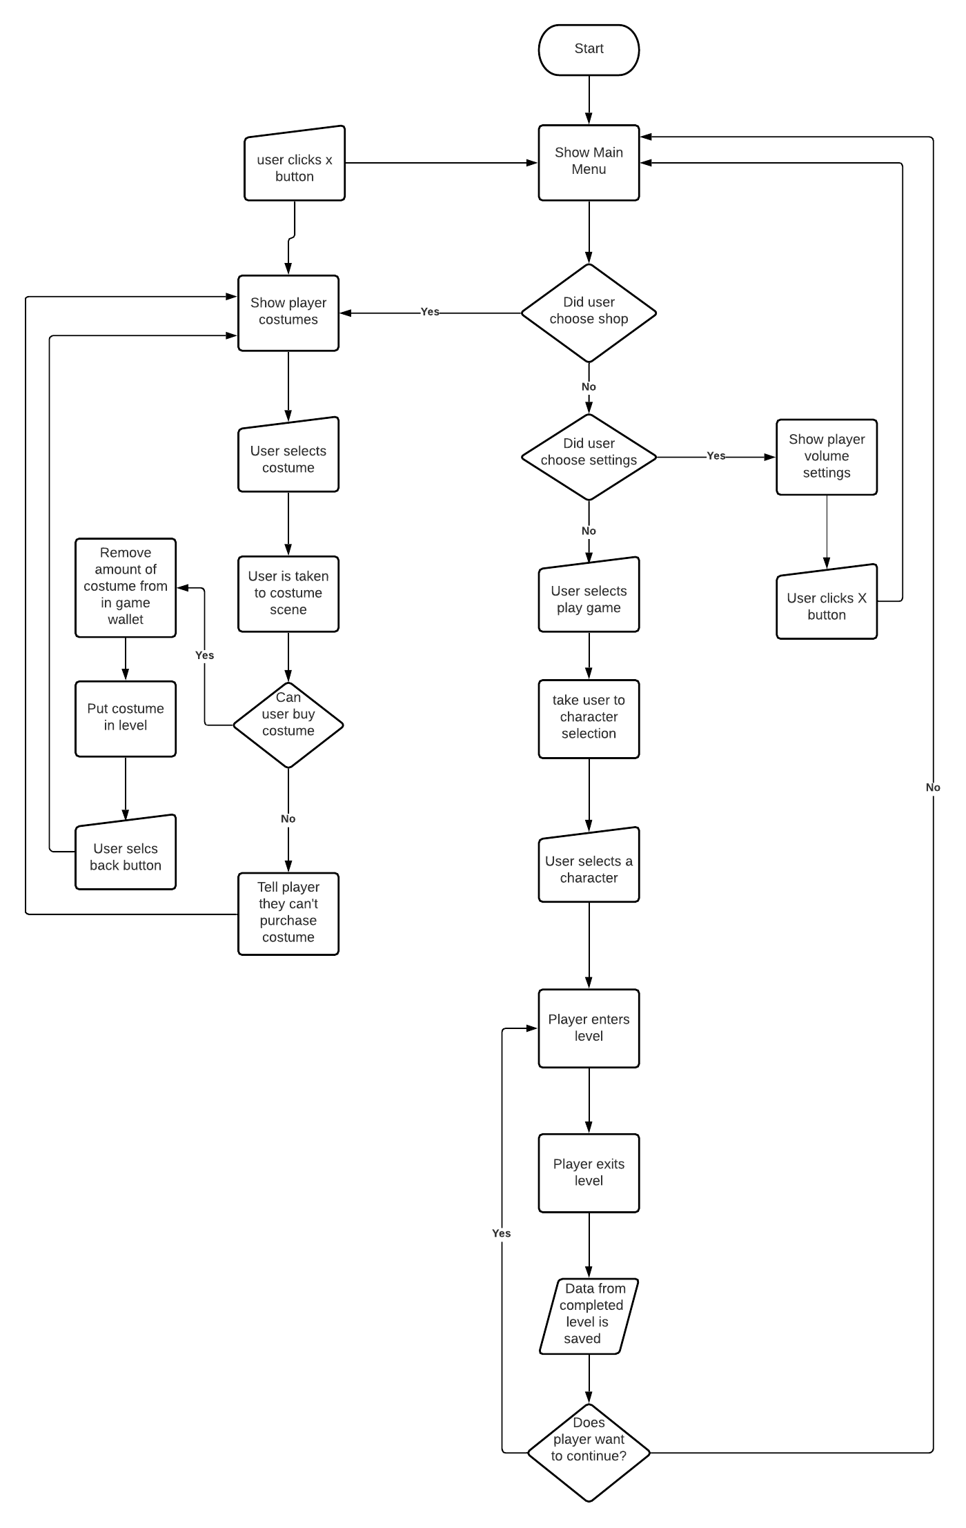

Project Controls

|  |  |  |  |  |
| --- | --- | --- | --- | --- |
| Risk Management | | | | |
|  | **Risk Probability** | **Risk Impact** |  |  |
| **Event Risk** | **(high, medium, low)** | **Risk Mitigation** | **Contingency Plan** |
| What is the risk? | What is the probability? | What is the impact if the risk occurs? | What can be done to minimize the risk? | What can be done to minimize the impact of the risk? |
| Not knowing the Swift language | medium | The project will not be able to be completed in the chosen language | Complete tutorials and build applications to increase knowledge | Make the application in Java. |
| Haven’t done mobile development | medium | The project will not be able to be completed in this format | Complete tutorials and build applications to increase knowledge | Make the application for desktop instead |
| Haven’t done game development | medium | The project will not be able to be completed | Complete tutorials and build applications to increase knowledge | Keep the features within skill level |
| Haven’t used Realm, Core Data, or SQLlite databases | high | The data will not be recorded, so the user would have to start over every time they play | Complete tutorials and build applications to increase knowledge | Store the data in another database or in an array for demo purposes |
| An iOS or Xcode update could break the application | low | The update could break a feature within the application itself, or a feature in XCode could be temporarily broken while developing | Read all update changes before updating both XCode and the iOS version that is being used for development | Keep either a device with a working iOS and review outside sources to check if a feature was removed or broken with an update |

|  |  |  |  |  |  |  |  |  |
| --- | --- | --- | --- | --- | --- | --- | --- | --- |
| Issues Log | | | | | | | | |
| **ID** | **Description** | **Project Impact** | **Action Plan/Resolution** | **Owner** | **Importance** | **Date Entered** | **Date to Review** | **Date Resolved** |
| 1 | What is the issue? | How will this impact scope, schedule & cost? | How do you intend to deal with this issue? | Who manages this issue? |  |  |  |  |
| 2 | There are no issues at this time |  |  |  |  |  |  |  |

Appendix A – References

Beginner Lesson Resources. (2019, September 04). Retrieved from https://codewithchris.com/beginner-youtube/

How to Make an App for Beginners (2020). (n.d.). Retrieved from https://www.youtube.com/playlist?list=PLMRqhzcHGw1ZkH8RuznGMS0NZs0jWQQ5a

Inc., A. (n.d.). Swift.org. Retrieved from https://docs.swift.org/swift-book/

Technologies. (n.d.). Retrieved from https://developer.apple.com/documentation/technologies

Appendix B – Copyright Compliance

This project does not violate any known copyright claims.